**Lab Exercise 2– Terraform AWS Provider and**

**IAM User Setting**

Prerequisites: Terraform Installed: Make sure you have Terraform

installed on your machine. Follow the official installation guide if needed.

**Exercise Steps: Step 1: Create a New Directory: Create a new directory for your Terraform configuration:**

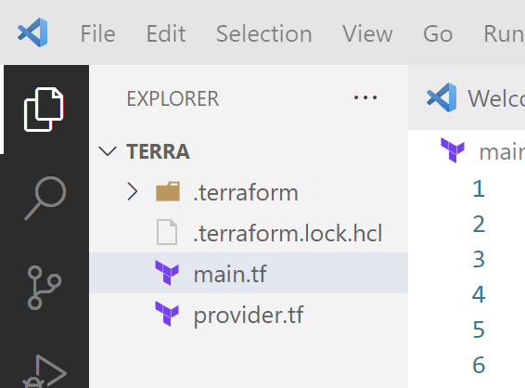

**Step 2: Create Terraform Configuration File (main.tf):**

Create a file named main.tf with the following content:

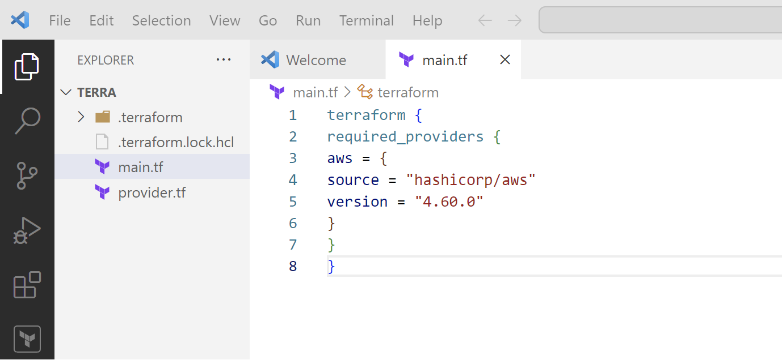

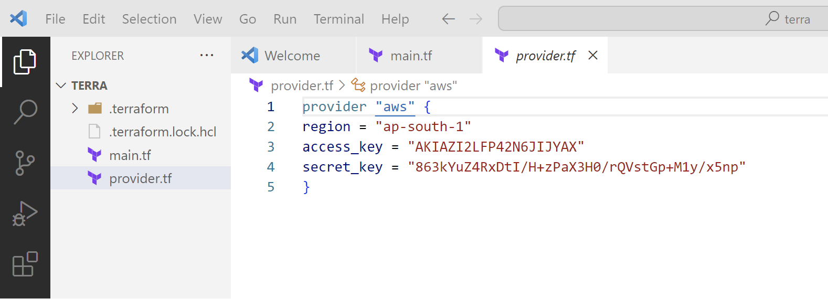

This script defines an AWS provider and provisions an EC2 instance.

**Step 3: Initialize Terraform: Run the following command to initialize your Terraform working directory:**

